**Detailed Guide on NLP, LLMs, LSTMs, and Data Analysis in Machine Learning**

**1. Natural Language Processing (NLP)**

Natural Language Processing (NLP) is a field of artificial intelligence that focuses on the interaction between computers and human languages. NLP enables computers to process, understand, and generate text or speech.

**Key NLP Tasks and Techniques:**

* **Tokenization:** Splitting text into words or phrases (tokens) for analysis.
* **Stopword Removal:** Eliminating common words (e.g., "is", "and", "the") that do not contribute much meaning.
* **Lemmatization & Stemming:** Reducing words to their root form to normalize variations (e.g., "running" → "run").
* **Named Entity Recognition (NER):** Identifying proper names, organizations, and locations in text.
* **Part-of-Speech (POS) Tagging:** Assigning grammatical categories (e.g., noun, verb) to words.
* **Sentiment Analysis:** Determining whether a text conveys positive, negative, or neutral sentiment.
* **Text Classification:** Categorizing documents into predefined labels (e.g., spam detection).
* **Topic Modeling:** Discovering hidden themes in large collections of text.
* **Word Embeddings:** Representing words numerically using models like Word2Vec, GloVe, and FastText.
* **Transformer Models:** Advanced deep learning architectures like BERT and GPT that revolutionized NLP.

**Visualization: Word Cloud Representation of NLP Tasks**

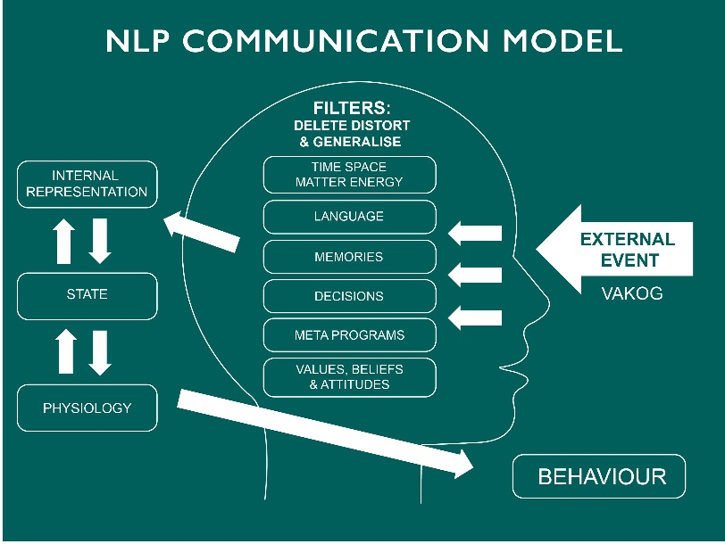 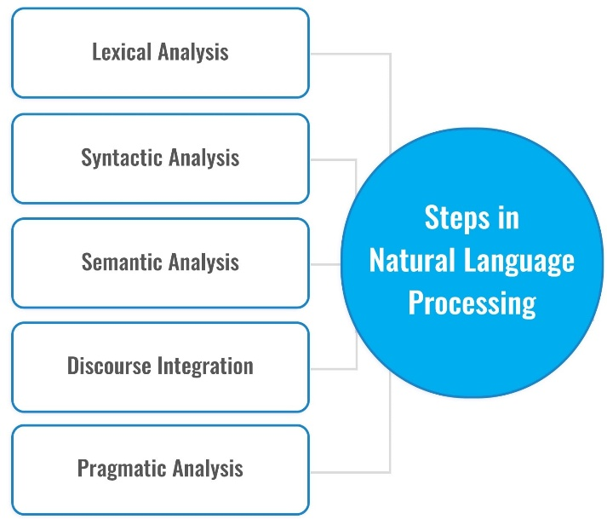

**2. Large Language Models (LLMs)**

Large Language Models (LLMs) like GPT-4 and BERT are deep learning models trained on vast amounts of text data. These models use self-attention mechanisms and transformer architectures to process and generate human-like text efficiently.

**How LLMs Work:**

* **Pretraining:** The model learns grammar, facts, and reasoning from a diverse corpus.
* **Fine-tuning:** It is further trained on specific tasks (e.g., chatbots, summarization).
* **Self-Attention Mechanism:** Unlike traditional RNNs, transformers focus on different words in a sentence simultaneously to understand the context.
* **Scaling Laws:** LLMs improve with increased data, parameters, and computation.

**Visualization:** 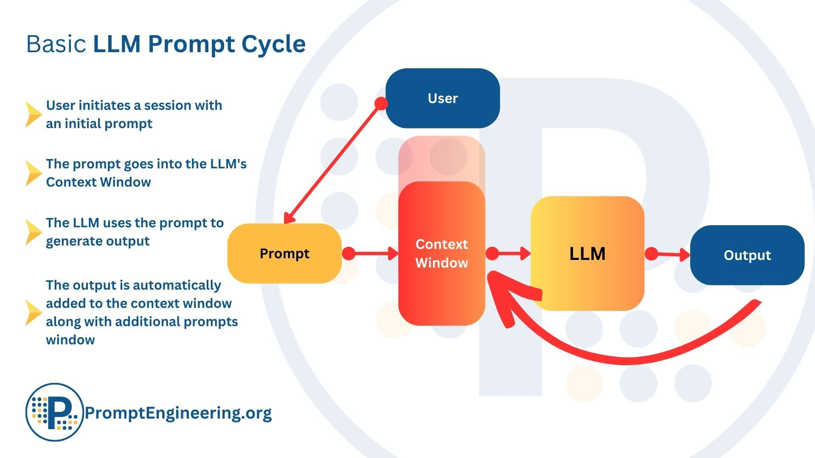

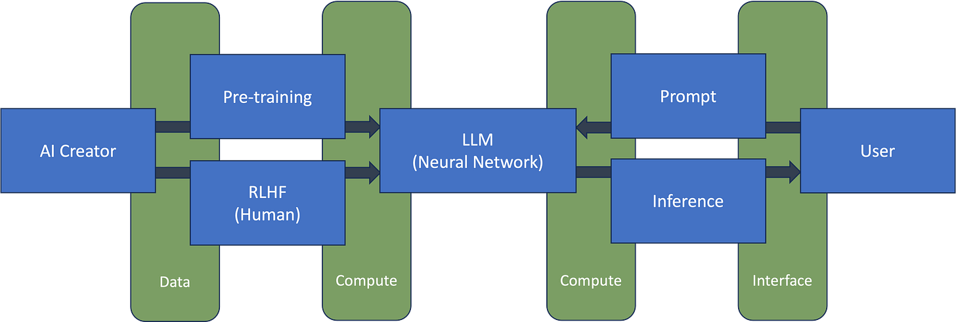

**3. Long Short-Term Memory (LSTM) Networks**

LSTMs are a type of Recurrent Neural Network (RNN) designed to overcome the issue of vanishing gradients in traditional RNNs. They are widely used for sequential data like time series forecasting, speech recognition, and text generation.

**Key Components of an LSTM Cell:**

* **Forget Gate:** Determines what information should be discarded from the previous state.
* **Input Gate:** Decides what new information should be stored in the cell state.
* **Output Gate:** Computes the hidden state for the next step based on the cell state.
* **Cell State:** Maintains long-term memory by allowing information to flow through time.
* **Hidden State:** Carries the short-term memory needed for immediate prediction.

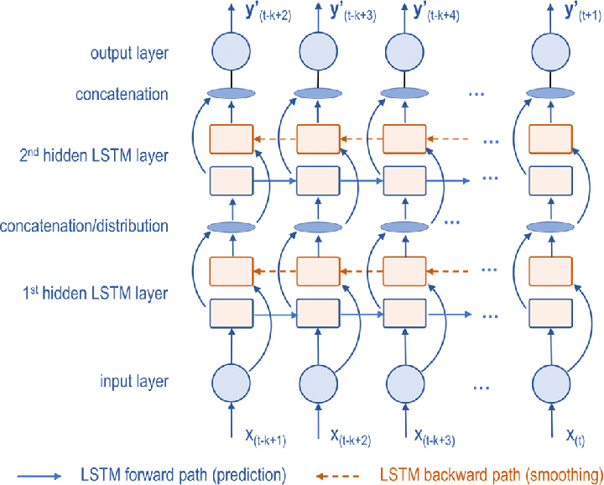**Visualization:**

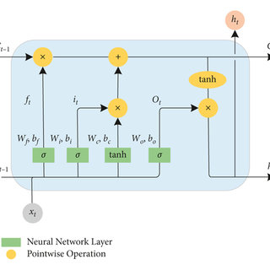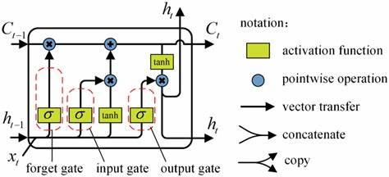

**4. Data Analysis and Machine Learning Models**

Before applying ML models, data analysis is crucial to understand patterns, distributions, and relationships between features.

**Steps in Data Analysis for ML:**

1. **Data Collection:** Gathering relevant structured or unstructured data.
2. **Exploratory Data Analysis (EDA):**
   * Checking missing values
   * Identifying outliers
   * Understanding feature distributions
3. **Feature Engineering:** Transforming raw data into meaningful input for ML models.
4. **Data Visualization:** Using charts like histograms, scatter plots, and box plots to analyze data trends.
5. **Correlation Analysis:** Identifying relationships between variables to improve model selection.

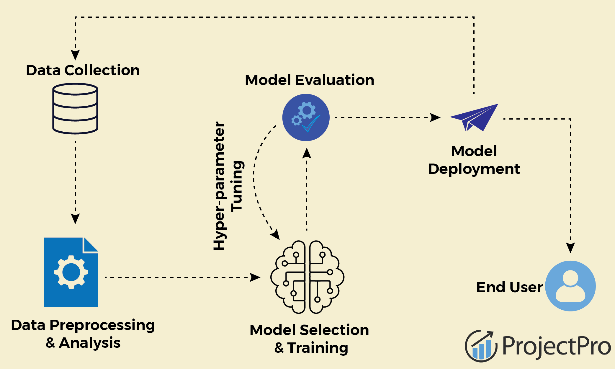

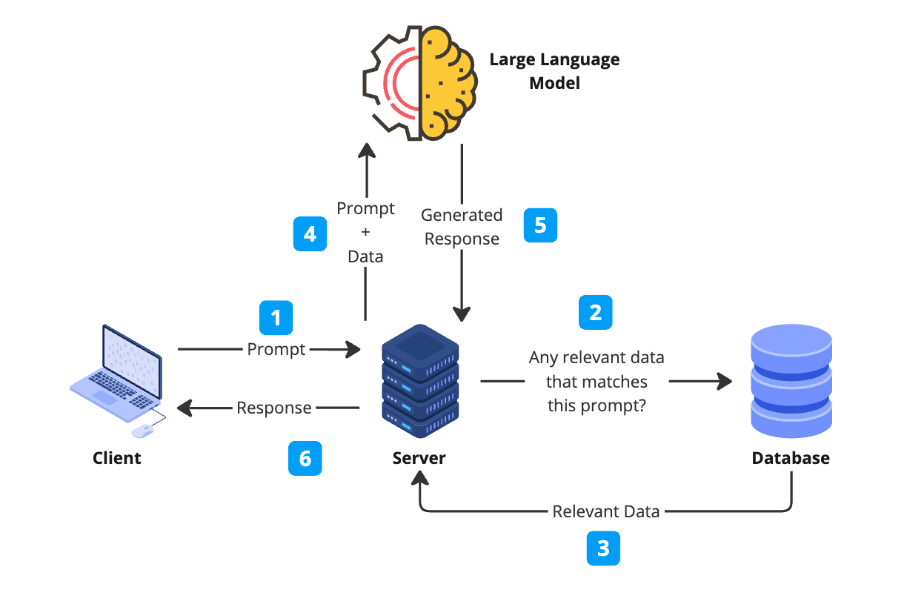

**Generative AI Maturity Model**